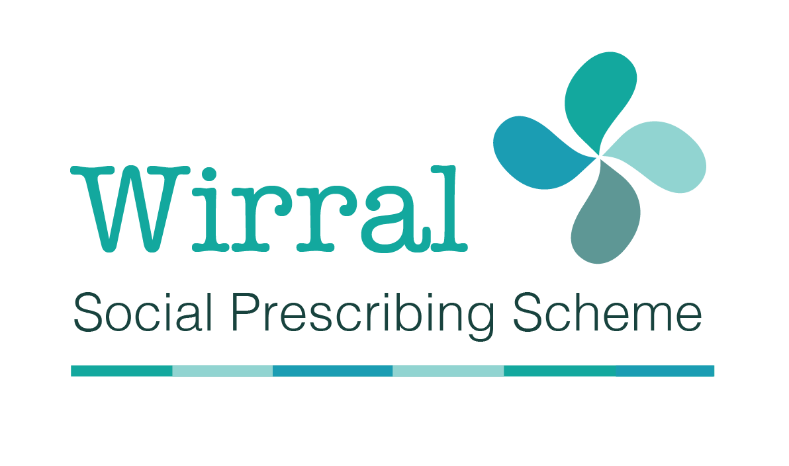
The Wirral Social Prescribing Scheme is an exciting new service for adult Wirral residents who have chronic breathing difficulties and are perhaps experiencing low mood, anxiety or depression.

We know that many of life’s problems can make us feel unwell. The Wirral Social Prescribing team can help you by giving you time to talk about what’s important to you; to help you identify issues and challenges you’d like to address and to find services and activities to support you in your local community.

We can help with
⦁ Money advice - benefits, debt, and budgeting
⦁ Healthy lifestyle advice and physical activity
⦁ Education and learning
⦁ Housing and welfare
⦁ Arts, gardening, cookery, creative activities
⦁ Befriending, counselling, relationships and groups
⦁ Employment, training and volunteering

The Wirral Social Prescribing Scheme enables a GP, nurse or other healthcare professional to refer you a Social Prescriber to talk about the issues you’re facing and find the right services to support you.

To be referred to the scheme or for more information talk to Mandy at the Cavendish Medical Centre on 0151 652 1955.
